ELEMENTS OF MACHINE DESIGN (EMD-22564)
QUESTION BANK (FIRST TEST)
Course:- ME5I
Questions for 2 marks
- Draw stress stain diagram for ductile and brittle material. Name various points on the diagram.(CO1)
- Explain the following stresses- i) Transverse shear stress, ii) Bending stress. (CO1)
- What are the steps involved in general design procedure? Explain in brief. (CO1)
- What is stress concentration? Illustrate methods to reduce it with sketches. (CO1)
- Explain the following stresses- i) Bearing pressure, ii) Crushing stress. (CO1)
- State the meaning of following designations:- i) 72W18Cr4v1, ii)11Mn2, iii) FG150, iv) FeE220, v) SG800/2, vi) FeE400, vii) 35Mn2Mo28, viii) CS840. (CO1)
- What do you mean by creep? (CO1)
- What do you mean by Fatigue failure? (CO1)
- Define factor of safety. (CO1)
- Define:- Brittleness, Malleability. (CO1)
- Draw and label creep curve and explain the effect of creep rate. (CO1)
- What is Ergonomics? (CO1)
- Give the importance of shape in aesthetic design. (CO1)
- What is Aesthetic? (CO1)
- Explain why tapper is provided on cotter? Give recommended values of taper. (CO2)
- State any two applications each of a cotter and knuckle joint. (CO2)
- Distinguish between shaft and axle. What type of stresses are induced in shaft?(CO3)
- What is key ? State its applications. (CO3)
Questions for 6 marks:-
- Design a knuckle joint for a tie rod of a circular section to sustain a maximum pull of 70KN. The ultimate tensile and shear strength of the pin material are 510MPa and 396MPa respectively. Take factor of safety as 6. (CO2)
- Design a cotter joint for a maximum load of 6KN. The permissible stresses are 60N/mm² in tension, 100N/mm² in compression and 40N/mm² in shear. (CO2)
- Write strength equations in the design of cotter joint with relevant sketches. (CO2)
- Draw neat sketch of turn buckle and write the design procedure. (CO2)
- Design a Turn buckle to carry a load of 100KN. The tie rod and nut are made from same material having permissible tensile stress as 75N/mm² and permissible shear stress as 30N/mm². (CO2)

- An offset link subjected to a force of 30KN as shown in fig. If the permissible tensile stress is 55MPa, determine the dimensions of the cross-section of link. (CO2)

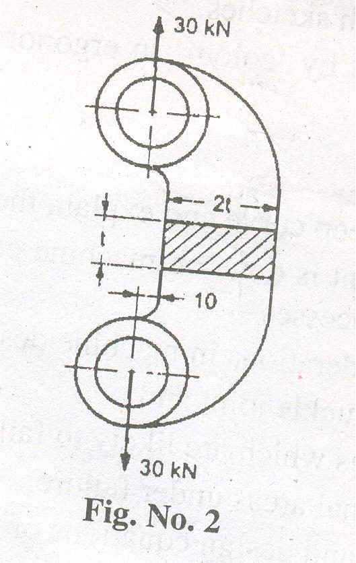

- Design ‘C’ clamp frame for a total clamping force of 20KN. The cross-section of the frame is rectangular and width to thickness ratio is 2. The distance between the load line and the neutral axis of rectangular section is 120mm and the gap between two faces is 180mm. Frame is made of cast iron. The permissible tensile stress for cast iron is 100N/mm². (CO2)
- Design a right angled bell crank lever. The horizontal arm is 500mm long and load of 4.5KN acts vertically downwards through a pin at the end of this arm. At the end of 150mm long arm which is perpendicular to the 500mm long arm, a force P acts at right angles to axis of 150mm arm through a pin at the end. The lever consists of forged steel material and a pin at fulcrum. Take following data for both pin and lever material:-
Tensile/compressive/bending stress = 75MPa
Shear stress = 60MPa, Bearing pressure = 10N/mm².
Assume width of lever 3 times thickness of lever. (CO2)
- A simple cotter joint is subjected to an axial load of 100KN. Allowable stresses for the material are 80N/mm² in tension, 35N/mm² in shear and 100N/mm² in compression. The joint is subjected to 30% overload due to tightening. Design the joint. (CO2)
- Design a knuckle joint to transmit 150KN, the design stresses may be taken as 75MPa in tension, 60MPa in shear and 150MPa in compression. (CO2)
- A line shaft is driven by means of a motor placed vertically below it. The pulley on the line shaft is 1.5mt. in diameter and has belt tensions of 5.4KN and 1.8KN on the tight side and slack side of the belt respectively. Both these tensions may be assumed to be vertical. The pulley is overhang from the shaft, the distance from center line of pulley to the center of bearing is 400mm. assume maximum allowable shear stress of 42MPa. Determine the diameter if the shaft. (CO3)
- A shaft made of mild steel is required to transmit 100KW at 300rpm. The supported length of the shaft is 3mt. It carries two pulleys each weighing 1500N supported at a distance of 1mt. from the ends respectively. Assuming 42MPa of shear stress, determine the diameter of the shaft.(CO3)

