BHARATI VIDYAPEETH INSTITUTE OF TECHNOLOGY QUESTION BANK

Unit Test-I (Shift:-I & II)

Program : - Computer Engineering Group Program Code:- CM/IF Course Title: -Advanced Java Programming Semester: - Fifth Course Abbr &Code:-AJP (22517) Scheme: I --------------------------------------------------------------------------------------------------
CHAPTER-1 (Abstract Windowing Toolkit (AWT)) (CO1 And CO2)
1.Which of these methods is a part of Abstract Window Toolkit (AWT) ?

a) display()
b) print()
c) drawString()
d) transient()

2. Which of these operators can be used to get run time information about an object?

a) getInfo
b) Info
c) instanceof
d) getinfoof

3. Which of these package is used for handling security related issues in a program?

a) java.security
b) java.lang.security
c) java.awt.image
d) java.io.security

4. The order of the three top level elements of the java source file are___.

a. Import, Package, Class
b. Class, Import, Package
c. Package, Import, Class
d. Random order

5. Which one is not supported by OOP?

a. Abstraction
b. Polymorphism
c. Encapsulation
d. Global variables

6. Java programs are_____.

a. Platform-dependent
b. Interpreter-dependent
c. Platform-independent
d. Interpreter-independent

7. The new operator_____.

a. returns a pointer to a variable
b. creates a variable called new
c. obtains memory for a new variable
d. tells how much memory is available

8. Java language has support for which of the following types of comment?

a. block, line and javadoc
b. javadoc, literal and string
c. javadoc, char and string
d. single, multiple and quote

9. Command to execute a compiled java program is :

a. javac
b. java
c. run
d. execute

10. ______ is a mechanism for naming and visibility control of a class and its content.

a. Object
b. Packages
c. Interfaces
d. None of the Mentioned

11. The java compiler____.

a. creates executable
b. translates java source code to byte code
c. creates classes
d. produces java Interpreter

12. Where are the following four methods commonly used?
1) public void add(Component c)
2) public void setSize(int width,int height)
3) public void setLayout(LayoutManager m)
4) public void setVisible(boolean)
a. Graphics class
b. Component class
c. Both A & B
d. None of the above

13. Which is the container that doesn't contain title bar and MenuBars but it can have other components like button, textfield etc?
a. Window
b. Frame
c. Panel
d. Container

14. Which is used to store data and partial results, as well as to perform dynamic linking, return values for methods, and dispatch exceptions?

a. Window
b. Panel
c. Frame
d. Container

15. AWT has more powerful components like tables, lists, scroll panes, color chooser, tabbed pane etc.
a. True
b. False
16. Which are passive controls that do not support any interaction with the user?
a. Choice
b. List
c. Labels
d. Checkbox

17. For windows, the default layout manager is ________.

a) BorderLayout
b)FlowLayout
c)GridLayout
d)GridBagLayout

18. The SecurityManager object is responsible for implementing the security policies for applets.

a)True
b)False
19. Applets loaded from the same computer where they are executing have the same restrictions as applets loaded from the network.

a)True
b)False

20. One of the popular uses of applets involves making connections to the host they came from.

a)True
b)False

21. An applet may not create frames (instances of java.awt.Frame class).

a)True
b)False
22. Which of the following methods can be used to remove a java.awt.Component object from the display?

a)hide()
b)delete()
c)disappear()
d)move()

23. The setBackground() method is part of the following class in java.awt package:

a)Graphics
b)Container
c)Component
d)Applet

24. Panel and Dialog boxes can have menubar.

a)True
b)False

25. In the following statements which is a drawback for Applet?
a) It works at client side so less response time
b) Secured
c) It can be executed by browsers running under many platforms, including Linux, Windows, and Mac Os etc.
d)Plugin is required at client browser to execute applet

26. The java.applet.Applet class 4 life cycle methods and java.awt.Component class provides how many
life cycle methods for an applet?

a)1
b)2
c)3
d)4

27. Which life cycle method of an applet java.awt.Component class provides?
a) public void paint(Graphics g)
b) public void destroy()
c) public void stop()
d) public void init()

28. Which is invoked after the init() method or browser is maximized?
a) public void start()
b) public void paint(Graphics g)
c) Public void stop()
d) Public void init()

29. Which is the correct order for lifecycle of an applet?
a) Applet is intialized,started,painted,destroyed,stopped
b) Applet is painted,started,stopped,initilaized,destroyed
c) Applet is initialized,started,painted,stopped,destroyed
d) None of the above

30. To run an Applet which of these used?
a) By html file
b) By AppletViewer tool(for testing purpose)
c) Both A & B
d) None of the above

31. Java Plug-in software is not responsible to manage the lifecycle of an Applet?
a) True
b) False

32. Which Called when an applet begins execution, It is the first method called for any applet?
A) void init()
B) void destroy()
C) boolean isActive()
D) None of the above

33. When an applet begins, the AWT calls the following methods, in this sequence?
a) init(),paint(),start()
b) Start(),paint(),init()
c) intit(),start(),paint()
d) paint(),start(),init()

34. when an applet is terminated the following sequence of methods calls takes place?
a) stop(),paint(),destroy()
b) destroy(),stop(),paint()
c) destroy(),stop()
d) stop(),destroy()

35. This method is used to suspend threads that don’t need to run when the applet is not visible?
a) destroy()
b) paint()
c) stop()
d) start()

36. Which method is called only once during the run time of your applet?
a) stop()
b) paint()
c) init()
d) destroy()

37) The APPLET tag is used to start an applet from both an HTML document and from an applet viewer?
A) True
B) False
38) Which is a required attribute that gives the name of the file containing your applet’s compiled .class file?
a) CODE
b) CODEBASE
c) ALT
d) NAME
39) Applet works at client side so less response time?
a) True
b) False
40) Applet runs inside the browser and does not works at client side?
a) True
b) False
41) In Applet which are common security restrictions?
a) Applets can't load libraries or define native methods
b) An applet can't read every system property
c) Applets can play sounds
d) Both A & B
42) Which Invoked immediately after the start() method, and also any time the applet needs to repaint itself in the browser?
a) stop()
b) init()
c) paint()
d) destroy()
43) An applet can play an audio file represented by the AudioClip interface in the java.applet package. The AudioClip interface has how many methods?
a) 2
b) 3
c) 1
d) 4
44) An applet can play an audio file represented by the AudioClip interface in the java,applet package Causes the audio clip to replay continually in which method?
a) public void play()
b) public void loop()
c) public void stop()
d) None of the above
45. Applets cannot make network connection exception to the server host from which it originated?
a) True
b) False

46. The following way is used to create a frame is by creating the object of Frame class?
a) inheritance
b) association
c) Both A & B
d) None of the above
Ans : b
47. The Java Foundation Classes (JFC) is a set of GUI components which simplify the development of desktop applications?
a) True
b) False

48. Which inheritance is not supported in java?
a) Single inheritance
b) Hybrid inheritance
c) Multilevel inheritance
d) Java supports all of the above

49. Which is a mechanism in which one object acquires all the properties and behaviors of parent object?
a) Inheritance
b) Encapsulation
c) Polymorphism
d) None of the above

50. Which inheritance is not supported in java?
A) Single inheritance
B) Hybrid inheritance
C) Multilevel inheritance
D) Java supports all of the above
51. Which is a mechanism in which one object acquires all the properties and behaviors of parent object?
a) Inheritance
b) Encapsulation
c) Polymorphism
d) None of the above
52. The following Syntax is used for?
class Subclass-name extends Superclass-name
{
//methods and fields
}
a) Polymorphism
b) Encapsulation
c) Inheritance
d) None of the above
53. If subclass (child class) has the same method as declared in the parent class, it is known as?
a) Method overriding
b) Method overloading
c) Constructor overloading
d) None of the above
54. In Method overriding a subclass in a different package can only override the non-final methods declared public or protected?
a) True
b) False
55. Which allows you define one interface and have multiple implementations?
a) Encapsulation
b) Inheritance
c) Polymorphism
d) None of the above
56. Which type of polymorphism is nothing but the method overloading in java?
a) Compile time polymorphism
b) Runtime polymorphism
c) Static polymorphism
d) Both A & C
57) Which is a perfect example of runtime polymorphism?
a) Method overloading
b) Method overriding
c) Constructor overloading
d) None of the above
58) The following two rules are defined by?
1. The parameters may differ in their type or number, or in both.
2. They may have the same or different return types.
a) Method overloading
b) Method overriding
c) Constructor overloading
d) None of the above
59. Which method cannot be overridden?
a) Final Method
b) Final class
c) Final Variable
d) Both A & C
60. A final class not to be inherited?
a) True
b) False
61. A class which cannot be instantiated is known as?
a) Abstract Class
b) Abstract Method
c) Both A & B
d) None of the above
62. An abstract class has no use until unless it is extended by some other class?
a) True
b) False
63. Multiple inheritances is not supported in case of class but it is supported in case of interface?
a) True
b) False
64. By interface, we cannot support the functionality of multiple inheritances?
a) True
b) False
65. Which keyword is used by classes to implement an interface?
a) import
b) implements
c) instance of
d) None of the above
66. An interface is a blueprint of a class. It has static constants and abstract methods?
a) True
b) False

67. Which is a superclass of all exception classes?
a) Throwable
b) Exception
c) RuntimeException
d) IOException
68. The general form to set a specific type of layout manager is

a) Void setLayout(Layoutmanager Im)
b) void setLayout(layoutManager Im)
c) Void setLayout(LayoutManager lm)
d) voidsetLayout(LayoutManager Im)

69. getSelectedCheckbox() method of which class.

a) CheckboxGroup
b) Checkbox
c) Choice
d) List

70.Which method is use to check the status of check box?

a) setState()
b) getState()
c) setLabel()
d) getLabel()

71._________arranges the component in rows and coloumn.

a)BorderLayout
b)FlowLayout
c)GridLayout
d)CardLayout

72.What is the return type of getItem()?

a)Object
b)int
c)String
d)All of these

73. Container class is subclass of Component class.

a)True
b)False

74. Container class is mainly responsible for positioning components on a window.

a)True
b)False

75. Window class is base class for two window classes 1)_____2)____.

a)Panel and Frame
b)Component and Frame
c)Window and Panel
d) Component and Panel

76. We cannot place any component object into Window

a)True
b)False

77.For a TextArea that is 80 character-widths wide and 10 character-heights tall,which is the correct code?

a)new TextArea(80,10)
b)new TextArea(10,80)
c)New TextArea(10,80)
d)new Textarea(80,10)

78. The CheckboxGroup class is the subclass of the Component class.

a)True
b)False

79. A Scrollbar is a ____.

a)Component
b)Container
c)Object
d)None of the above

80. A ScrollPane is a _____.

a)Component
b)object
c) Container
d) None of the above

81. Which component subclass is used for drawing and painting?

a)Repaint
b)Graphic
c)Paint
d)Canvas

82. Which method is used to set text of a Label object?
a)setText()
b)setLabel
c)setTextLabel()
d)setLabelText()

83. Which of the following creates a List with 5 visible items and multiple selection enabled?
a)new List(5,true)
b) new List(true,5)
c) new List(5,false)
d) new List(false,5)

84. Which method will cause Frame to be displayed?

a)show()
b)display()
c)displayFrame()
d)setVisible()

85. The Choice Component alows multiple selection.

a)True
b)False

86. The List component does not generate any events.

a)True
b)False

87. Which is the Default Layout Manager for Window and window subclasses(Frame,Dialog)?
a) CardLayout
b)FlowLayout
c)BorderLayout
d)GridLayout

89. Which method is the method to set the Layout of the Container?

a)startLayout()
b)intLayout()
c)layoutContainer()
d)setLayout()

90. Which Layout is for organizing the componets in the tabular form?

a) CardLayout
b)FlowLayout
c)BorderLayout
d)GridLayout

91. Which is the dual state MenuItem?

a)CheckboxMenuItem
b)MenuItem
c)MenuItemCheckbox
d)None of the above

92. CheckboxMenuItem class extends MenuItem class.

a)True
b)False

93. Window is the Container that have no borders and manu bars.

a)True
b)False

94. Java Plug-in software is responsible to manage the life cycle of an applet ?

a)True
b)False

95. The classes which directly inherit Throwable class except RuntimeException and Error are known as checked exceptions .

a)True
b)False

96. The classes which inherit RuntimeException are known as unchecked exceptions.

a)True
b)False

97. The ____ keyword is used to declare exceptions.

a)catch
b) throws
c) throw
d)finally

98. _______is used to place important code, it will be executed whether exception is handled or not.

a) Finalize
b) Final
c) Finally
d)None of the above

99. Java throw keyword is used to explicitly throw an exception.

a)True
b)False

99. JVM (Java Virtual Machine) is an abstract machine.

a)True
b)False

100. JVM is called a virtual machine because it doesn't physically exist.

a)True
b)False
101. The Java Runtime Environment is a set of software tools which are used for developing Java applications.

a)True
b)False

102. The Java Development Kit (JDK) is a software development environment which is used to develop Java applications and applets.

a)True
b)False

103.JDK contains JRE + development tools.

a)True
b)False

104. A local variable can be defined with "static" keyword.

a)True
b)False

105. Memory allocation for static variable happens only once when the class is loaded in the memory.

a)True
b)False

106. If there is no constructor in a class, compiler automatically creates a default constructor.

a)True
b)False

107. A constructor must have a return type.

a)True
b)False

108. A method must have a return type.

a)True
b)False

109. “ this” keyword is a ______ variable that refers to the current object.

a)Private
b)Local
c) reference
d)Static

110. Interface cannot be instantiated just like the abstract class.

a)True
b)False

111. The _____ class is the parent class of all the classes in java by default.

a) Object
b) Container
c)Component
d)None of the above

112. _____package provides for system input and output through data streams, serialization and the file system.
a) java.swing
b) java.awt
c) java.lang
d)java.io

113. Java.lang package in Java Provides classes that are fundamental to the design of the Java programming language.

a) True
b) False

114. The _____class implements a growable array of objects.

a) Vector
b) Array
c)Both a) and b)
d)None of the above

115. Threads can be created by using mechanism:
a) Extending the Thread class
b) Implementing the Runnable Interface
c)Both a) and b)
d) None of the above

116.The Frame is by default invisible.

a) True
b) False

117. The TextField used for taking passwords, should be defined by calling_____.

a)setEchoChar()
b) EchoCharset()
c)setPassword()
d) passwordSet()

118.TextArea is a multiline TextField.

a)True
b)False

119.Only a Frame class can have menubar.

a)True
b)False

CHAPTER-2 (Swings) (CO1 And CO2)

Q.1 Pluggable look and feel and lightweight components are the features supported by ____.
a) Swing b) AWT
c) Core Java d) None of these
Q.2 Swing is based on ________ architecture.
a) Client server b) model view controller
c) Layered d) None of these
Q.3 Swing is not a part of JFC (Java Foundation Classes) that is used to create GUI application.
a) True b) False
Q.4 The Java Foundation Classes (JFC) is a set of GUI components which simplify the development
of desktop applications
a) True b) False
Q.5 Following letter used as a prefix to swing component.
a) A b) S
c) G d) J
Q.6 _______ is one of the features of object oriented programming that allows creation of
hierarchical classifications.
a) Polymorphism b) Class
c) Inheritance d) Object
Q.7 In swing JButton class is derived from ______.
a) Abstract Button b) JToggleButton
c) JComponent d) None of these

Q.8 The JTextComponent derives two components JTextField and _______.
a) JComboBox b) JTextArea
c) JSlider d) All of the above
Q.9 In swing class hierarchy the class present at the root is ______.
a) Component b) Window
c) Container d) Object
Q.10 ________ pane can be used to add component to container.
a) Glass b) Content
c) Container d) All of above
Q.11 Select the correct source code using swing for generating following output.

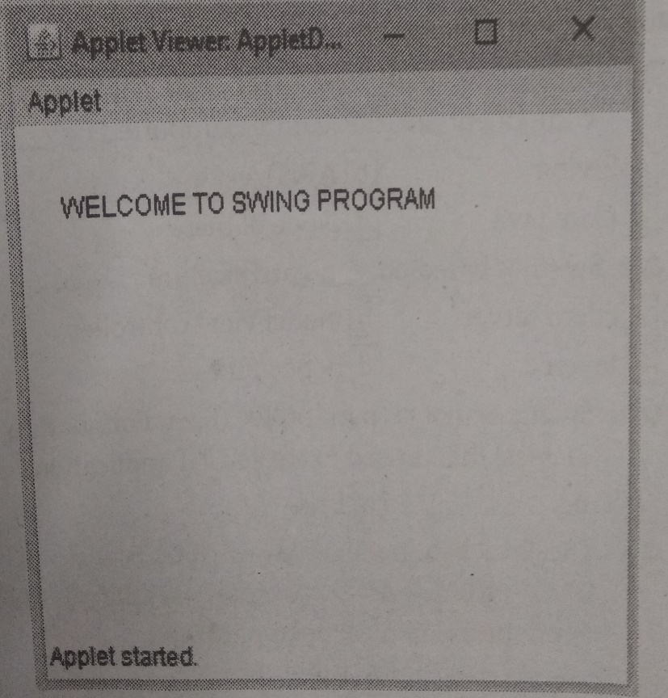

a)  public class AppletDemo extends JApplet  {  public void paint(Graphics g)  {  g.string(“WELCOME TO SWING PROGRAM ”,20,40);  }  } | b)  public class AppletDemo extends JApplet  {  public void paint(Graphics g)  {  g.drawString(“WELCOME TO SWING PROGRAM ”,20,40);  }  }
c)  public class AppletDemo  {  public void paint(Graphics g)  {  g.drawString(“WELCOME TO SWING PROGRAM ”,20,40);  }  } | d)  public class AppletDemo extends JApplet  {  public void paint(Graphics g)  {  g.display(“WELCOME TO SWING PROGRAM ”,20,40);  }  }

Q.12 The component used to display following image are _______.
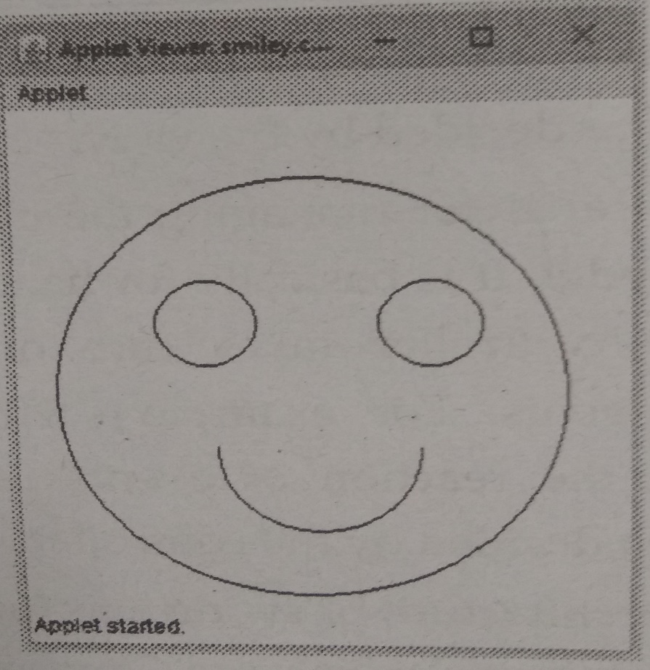
a) two circle, two arcs
b) three circle, one arc and one rectangle
c) Four circles
d) three circles and one arc
Q.13 To represent Icon file in swing label we use
a) setimg b) setIcon
c) setLabelIcon d) None of these
Q.14 Which of the following component allows multiple selection?
a) JList b) JComboBox
c) JLabel d) All of the above
Q.15 To generate above output we need _______.
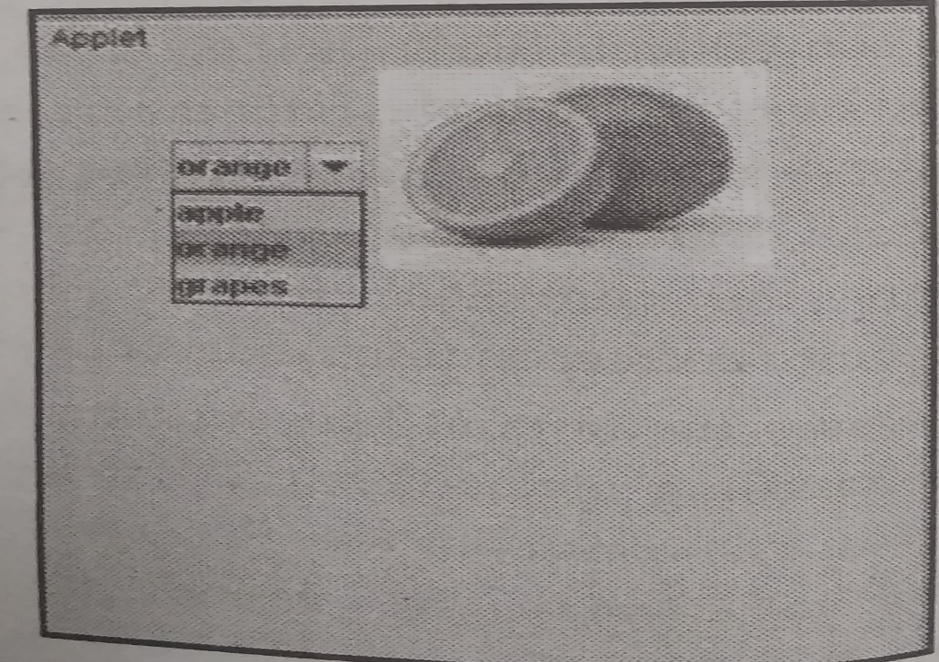
a) List, choice,Button, ImageIcon
b) ComboBox, ImageIcon, Label
c) List and Image Icon
d) ComboBox and ImageIcon
Q.16 To generate following output the components that are used are _______.
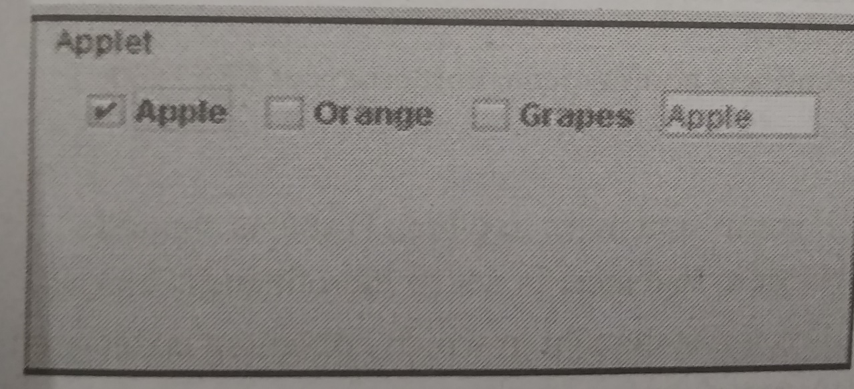
a) Checkbox, Textbox b) Radiobutton, Textbox
c) Checkbox, Button d) List, Textbox

Q.17 The subclass of JToggleButton is ______.
a) JButton b) JCheckBox
c) JRadioButton d) Both b and c
Q.18 The swing component classes that are used in Encapsulates a mutually exclusive set of buttons?
a) AbstractButton b) ButtonGroup
c) JButton d) ImageIcon
Q.19 Select the correct output generated by following code
import java.awt.*;
import java,applet.*;
/*<applet code=Test.class height=200 width=200>
</applet>*/Public class Test extends Applet
{
Public void init()
{
List l=new List(2,true);
l.add(“Java”);
l.add(“C++”);
l.add(“Python”);
add(l);
}
}

a)  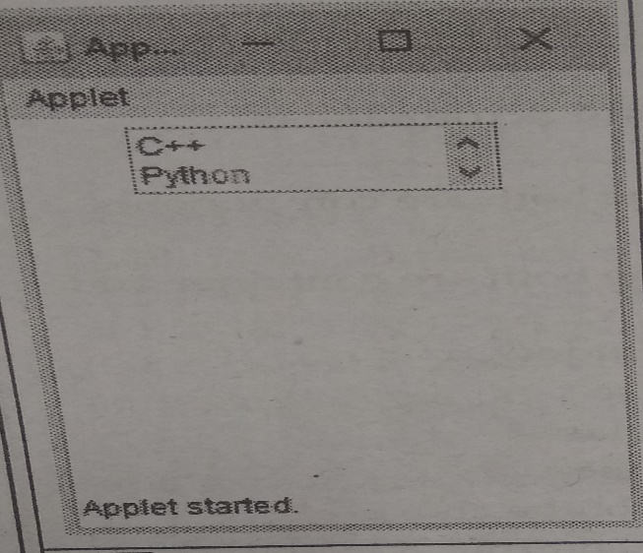 | b)  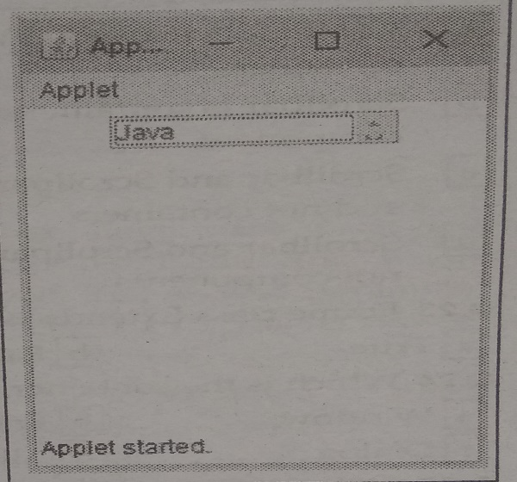
c)  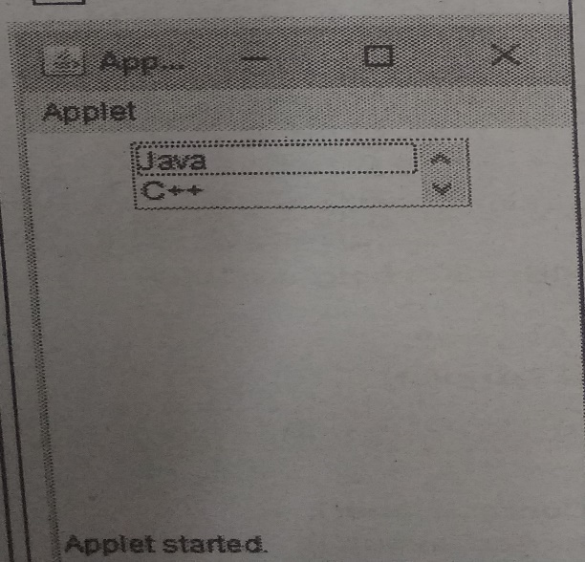 | d)  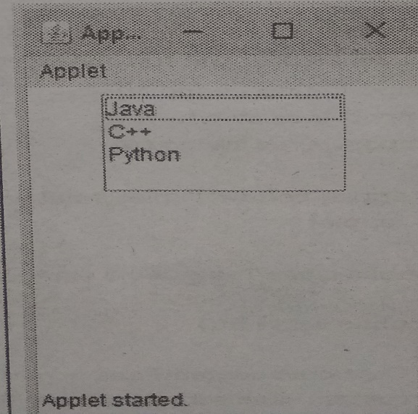

Q.20 Which method of the component class is used to set the position and size of a component.
a) setPosition b) setBounds
c) setSize d) None of these
Q.21 Select the correct option
I. Canvas is a component
II. ScrollPane is a container
a) I is true and II is false b) I is false and II is true
c) I and II both are false d) I and II both are true
Q.22 The difference between Scrollbar and Scrollpane is
a) Scrollbar is component and Scrollpane is container
b) Scrollbar is container and Scrollpane is component
c) Scrollbar and Scrollpane both are components and not containers
d) Scrollbar and Scrollpane both are containers and not components

Q.23 Frame class Extends Window.
a) True b) False
Q.24 Which is the container class?
a) Window b) Frame
c) Dialog d) All of the above
Q.25 Following is uneditable control
a) Button b) TextField
c) Label d) List

Q.26 Debug following program
import javax.swing.*;
import java.awt.*;
import javax.swing.tree.*;
/*<applet code=”TableDemo” width=300 height=100>
</applet>*/
public class TableDemo extends JApplet
{
public void init ()
{
Container contentPane=getContentPane();
contentPane.setLayout(new BorderLayout());
final String[] th={“Name”,”City”,”Salary”,”Designation”};
final Object[][] mytable={
{“Arun”,”Pune”,”5000”,”Accountant”},
{“Archana”,”Mumbai”,”7000”,”Executive”},
{“Shivani”,”Bangalore”,”10000”,”Manager”},
{“Priyanka”,”Chennai”,”8000”,”Programmer”},
{“Monika”,”Hyderabad”,”10000”,”Designer”},
{“Shilpa”,”Hyderabad”,”12000”,”Director”},
{“Anuja”,”Delhi”,”17000”,”Director”},
{“Kumar”,”Pune”,”10000”,”Manager”},
};
JTable table=new JTable(mytable);
int vscrollbar=ScrollPaneConstants.VERTICAL_SCROLLBAR_AS_NEEDED;
int hscrollbar= ScrollPaneConstants.HORIZONTAL_SCROLLBAR_AS_NEEDED;
JScrollPane mypane=new JScrollPane(table,vscrollbar,hscrollbar);
contentPane.add(mypane,BorderLayout.CENTER);
}
}
a) Error in statement in which JTable is created.
b) Error in statement in which JScrollPane is created
c) Error in statement in which applet tag is declared
d) None of these
Q.27 JPanel and Applet use _______ as their Default Layout.
a) FlowLayout b) GridLayout
c) BorderLayout d) GridBagLayout
Q.28 Which components are used to generate following output?
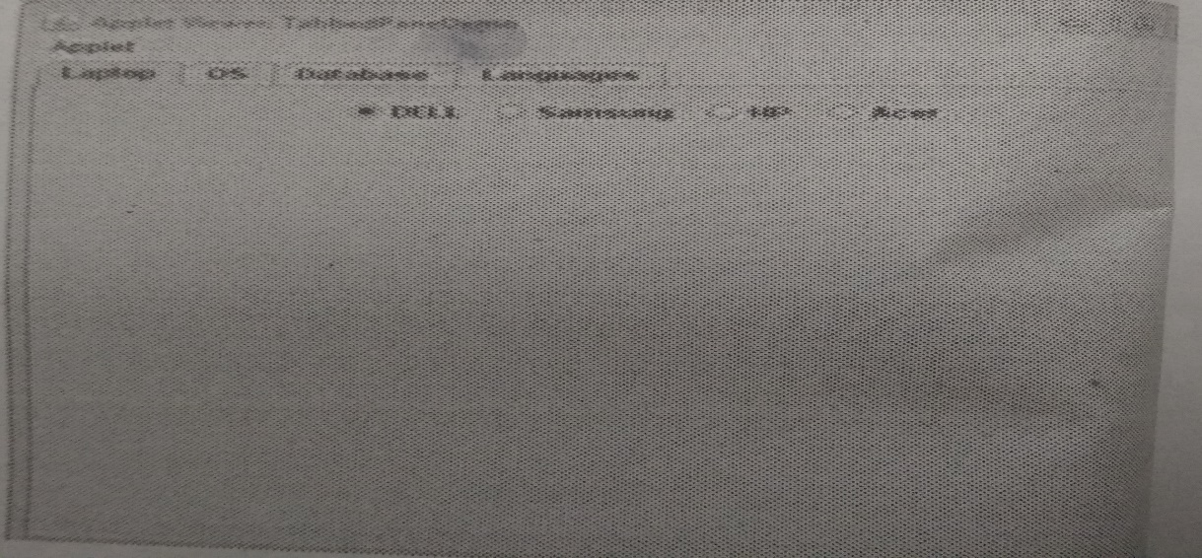
a) Panel, Tabbed Pane, Radio Button
b) Tabbed Pane, List
c) Tabbed Pane, Panel
d) Label, Tabbed Pane, Checkbox
Q.29 MVC stands for _______.
a) Model Version Control
b) Model View Controller
c) Mini View Controller
d) Major View Controller
Q.30 MVC architecture is used by Swing
a) True b) False
Q.31 In Swing ______ gives the visual representation of the component
a) Model b) View
c) Controller d) None of these

Q.32 In swing the event handling task is carried out by ______.
a) Model b) View
c) Controller d) None of these
Q.33 ______ represents enterprise data and the business rules that gives access to enterprise data.
a) Model b) View
c) Controller d) None of these
Q.34 A _____ is component that represents a hierarchical view of data .
a) JTable b) JTree
c) JMenuBar d) None of these
Q.35 We can use ______ pane to add component to container
a) contentpane b) rootpane
c) glasspane d) all
Q.36 In swing, the content pane can be obtained via method ______.
a) getContentPane b) addContentPane
c) both a&b d) None of these
Q.37 In a swing ____ is a component that display rows and columns of data.
a) table b) card
c) both a&b d) None of these
Q.38 In a swing, tables are implemented by the ______ class.
a) JPanel b) JTable
c) JTree d) None of these
Q.39 To use the swing components _____ package is imported.
a) java.awt b) java.swing
c) javax.swing d) None of these
Q.40 _____ is base class for all swing components.
a) Object b) JComponent
c) Container d) None of these
Q.41 The ______ is a fundamental swing class.
a) JApplet b)JFrame
c) JPanel d) None of these
Q.42 The JTextField is extended from _____ class.
a) JApplet b) JComponent
c) JFrame d) All of these
Q.43 JTextField has ____number of constructors.
a) 5 b) 4
c) 3 d) 2
Q.44 JCheckBox is implementation of _____ class.
a) JButton b) AbstractButton
c) JCheckBox d) None of these
Q.45 JCheckBox has _____ number of constructors.
a) 5 b) 2
c) 4 d) 3
Q.46 ______ is a component which contains group of folders.
a) TabbedPane b) JTabbedPane
c) both a&b d) None of these
Q.47 JTabbedPane class is extended by ______ class.
a) JComponent b) JApplet
c) JFrame d) None of these
Q.48 Which constructor is JComboBox class?
a) JComboBox() b) JcomboBox()
c) Both a&b d) JCombobox()
Q.49 Which method is used for add items in JComboBox?
a) add() b) addItem()
c) Both a&b d) None of these
Q.50 Which component is used for creating a GUI for downloading or transferring of file.
a) JLable b) JButton
c) JProgressBar d) JProgressbar
Q.51 Which panes are support to JApplet ?
a) Root Panes b) Glass Panes
c) Content Panes d) All of these
Q.52 All Swing components names start with J.
a) True b) False
Q.53 JProgressBar has _______ numbers of methods.
a) 3 b) 2
c) 4 d) 1
Q.54 You can create a tool tip for _________with setToolTipText() method.
a) JProgressBar b) JApplet
c) any JComponent d) None of these
Q.55 Which class is provide a general purpose component for implementing divider lines?
a) JProgressBar b) JComponent
c) JTable d) JSeparator
Q.56 Swing components are platform dependent.
a) False b) True
Q.57 Features of Java Foundation Classes (JFC) is:
a) Swing GUI components b) Look and Feel support
c) Java 2D d) All of these
Q.58 How many methods for ImageIcon?
a) 5 b) 1
c) 3 d) 2
Q.59 JTree has a 'root node' at the top most which is a parent for all nodes in the tree.
a) True b) False
Q.60 How many constructor for JTable?
a) 2 b) 1
c) 4 d) 5

CHAPTER-3 (Event Handling) (CO2 And CO3)

Q1. Which of these events generated when a button is pressed?
- WindowEvent
- ActionEvent
- KeyEvent
- ActionEvent
Q2. Method use to change the location of event?
- getPoint()
- translatePoint()
- getClickCount()
- isPopupTrigger()
Q3. Which method will be invoked if a character is entered?
- KeyPressed()
- KeyReleased()
- KeyTyped()
- KeyEntered()
Q4. Which of these is a super class of all adapter class?
- Applet
- Event
- ComponentEvent
- InputEvent
Q5. Which method used to obtain co-ordinates of a mouse?
- getPoint()
- GetCoordinates()
- GetMouseXY()
- GetMouseCoordinates()
Q6. Which of these is a super class of all ContainerEvent class?
- WindowEvent
- ComponentEvent
- ItemEvent
- InputEvent
Q7. Which of these class is super class of all events?
- EventObject
- EventClass
- ActionEvent
- ItemEvent
Q8. ____is a superclass of windowEvent class
- WindowEvent
- ComponentEvent
- ItemEvent
- InputEvent
Q9. Which of these package contains all the event handling interfaces?
- Java.lang
- Java.awt
- Java.awt.event
- Java.event
Q10. Name of event classes?
- ActionEvent,ComponentEvent
- ContainerEvent,FocusEvent
- ItemEvent,KeyEvent
- All of these
Q11. Event object class belongs to
- Java.util
- Java.awt
- Java.lang
- Java.sql
Q12. _____method is defined in mousemotionAdapter class
- MouseDragged()
- MousePressed()
- MouseReleased()
- MouseClicked()
Q13. Which of these constant value will change when the button at the end of scrollbar was clicked to increase its value?
- BLOCK_DECREMENT
- BLOCK_INCREMENT
- UNIT_DECREMENT
- UNIT_INCREMENT
Q14. Which constant of window Event class makes a request for closing window?
- WINDOW_CLOSED
- WINDOW_CLOSING
- WINDOW_ACTIVATED
- WINDOW_DEACTIVATED
Q15. ScrollBar implements____
- AdjustmentListener
- MouseListener
- ItemListener
- WindowListener
Q16. For which Interface method belongs to void adjustmentValueChanged(AdjustmentEvent e)?
- ObjectListener
- AdjustmentListener
- ActionListener
- ComponentListener
Q17. For which class this constant belongs to BLOCK_DECREMENT and BLOCK_INCREMENT?
- Scrollbar
- Menubar
- Filedialog
- Actionevent
Q19. Which of these events is generated when the size of component is changed?
- ComponentEvent
- ContainerEvent
- FocusEvent
- InputEvent

Q20. Which of these events is generated when the component is added or removed?
- ComponentEvent
- ContainerEvent
- FocusEvent
- InputEvent
Q21. Which of these are integer constants of ComponentEvent class?
- COMPONENT_HIDDEN
- COMPONENT_MOVED
- COMPONENT_RESIZE
- All of These
Q22. Which of these events is generated when computer gains or losses input focus?
- ComponentEvent
- ContainerEvent
- FocusEvent
- InputEvent
Q23. Base class of all AWT Event class is
- AwtEvent
- KeyEvent
- ActionEvent
- AdjustmentEvent
Q24. Which of these event generated when a button is Pressed?
- window Event
- ActionEvent
- KeyEvent
- MouseEvent
Q25. Which is the class responsible for handling key press activity?
- KeyEvent
- WindowEvent
- ActionEvent
- mouseEvent
Q26. Event class library is define in following package
- java.io
- java.util
- java.event
- java.object
Q27. ComponentEvent is a super class of __________
- Container Event
- FocusEvent
- both a and b
- None of these
Q28. TextEvent defines integer constant
- TEXT_VALUE_CHANGED
- TEXT_VALUE
- both a and b
- None of these
Q29. ____ is the abstract super class of all component input event class
- KeyEvent
- ItemEvent
- ActionEvent
- InputEvent
Q30. Event is called as
- change in the state of object
- change in the state of variable
- ActionEvent
- InputEvent
Q31. What is listener in context to event handling?
- is a variable that is notified when an event occurs
- is an object that is notified when an event occurs
- A listener is a method that is notified when an event occurs
- None of these
Q32. Event class is defined in which of these libraries
- java.io
- java.lang
- java.net
- java.util
Q33. Which of these method are used to register a keyboard event listener?
- KeyListener()
- ADDKeyListener()
- addKeyListener()
- eventKeyboardListener()

Q34. Which of these method can be used to obtain the command name for invoking actionEvent object?
- getCommand()
- getActionCommand()
- getActionEvent()
- getActionEventCommand()
Q35. Which of these events will be generated if we close an applet's window?
- ActionEvent
- ComponenrEvent
- AdjustmentEvent
- WindowEvent
Q36. Which of these integer constants defines in ActionEvent class?
- ALT_MASK
- CTRL_MASK
- SHIFT_MASK
- All of these

Q37. Which of these method can be used to determine the type of event?
- getID()
- getSource()
- getEvent()
- getEventObject()
Q38. Which of these class is super class of all the events?
- EventObject
- EventClass
- ActionEvent
- ItemEvent
Q39. Which of these method can be used to know the degree of adjustment made by the user?
- getValue()
- getAdjustmentType()
- getAdjustmentValue()
- getAdjustmentAmount()
Q40. Which of these methods can be used to determine the type of adjustment event?
- getType()
- getEventType()
- getAdjustmentType()
- getObjectEventType()
Q41. Which of these methods can be used to obtain the reference to the container that generated a containerEvent?
- getContainer()
- getContainerCommand()
- getActionEvent()
- getContainerEvent()
Q42. Which of these constant value will change when the button at the end of scrollbar was clicked to increase its value?
- BLOCK_DECREMENT
- BLOCK_INCREMENT
- UNIT_DECREMENT
- UNIT_INCREMENT

Q43. Which of these methods can be used to know which key is pressed?
- getKey()
- getModifier()
- getActionKey()
- getActionEvent()
Q44. Which of these methods can be used to obtain the coordinates of a mouse?
- getPoint()
- getCoordinates()
- GetMouseXY()
- getMouseCoordinates()
Q45. Which of these is superclass of container Event class?
- windowEvent
- ComponentEvent
- ItemEvent
- InputEvent
Q46. Which of these events is generated when computer gains or loses input focus?
- ComponentEvent
- ContainerEvent
- FocusEvent
- InputEvent
Q47. Which of these methods will respond when you click any button by mouse?
- mouseClicked()
- mouseReleased()
- mousePressed()
- All of these
Q48. Which of these interfaces defines a method actionPerformed()?
- ComponentListener
- ContainerListener
- ActionListener
- InputListener
Q49. Which of these is superclass of all adapter classes?
- Applet
- ComponentEvent
- Event
- InputEvent
Q50. Which of these methods will beinvoked if a character is entered?
- keyPressed()
- keyReleased()
- keyTyped()
- keyEntered()
Q51. ____method are used to register a mousemotion listener
- addMouse()
- addMouseListener()
- addMouseMotionListener()
- eventMouseMotionListener()
Q52. ___is super class of all the events.
- EventObject
- EventClass
- ActionEvent
- ItemEvent
Q53. If scrollbar is manipulated ____ event will be notified.
- ActionEvent
- ComponentEvent
- AdjustmentEvent
- windowEvent
Q54. which of these events is generated when a button is pressed?
- ActionEvent
- KeyEvent
- windowEvent
- Adjustmentevent

Q55. ____method can be used to determine the type of adjustment event.
- getType()
- getEventType()
- getAdjustmentType()
- getEventObjectType()
Q56. When the size of component is changed, ____ event is generated.
- ComponentEvent
- containerEvent
- FocusEvent
- InputEvent
Q57. When the component is added or removed, which of these events is generated.
- ComponentEvent
- containerEvent
- FocusEvent
- InputEvent
Q58. ____method can be used to obtain the reference to the container that generated a container.
- getContainer()
- getcontainerCommand()
- getActionEvent()
- getContainerEvent()
Q58. which of the following method can be used to get reference to a component that was affected by the container?
- getcomponent()
- getChild()
- getcontainercomponent()
- getcomponentChild()
Q59. ____event is generated when computer gains or losses input focus.
- ComponentEvent
- ContainerEvent
- FocusEvent
- InputEvent
Q60. FocusEvent is a subclass of _____ classes.
- ComponentEvent
- ContainerEvent
- ItemEvent
- InputEvent
Q61. ___can be used to know the type of focus change.
- typeFocus()
- typeEventFocus()
- isTemporary()
- isPermanent()
Q62. ___method can be used to change location of an event.
- ChangePoint()
- translatePoint()
- ChangeCoordinates()
- TranslateCoordinates()
Q63. Which of the following is integer constant of TextEvent class?
- TEXT_CHANGED
- TEXT_FORMAT_CHANGED
- TEXT_VALUE_CHANGED
- TEXT_SIZE_CHANGED
Q64. ___is used to obtain the object that generated a windowEvent.
- getMethod()
- getWindow()
- getWindowEvent()
- getWindowObject()
Q65. MouseEvent is subclass of___classes.
- ComponentEvent
- ContainerEvent
- ItemEvent
- InputEvent
Q66. ___method is used to get X coordinates of the mouse.
- getX()
- getXCoordinate()
- getCoordinateX()
- getPointX()
Q67. which of these are constants defined in windowEvent class?
- WINDOW_ACTIVATED
- WINDOW_CLOSED
- WINDOW_DEICONIFIED
- All of these

Q68. ___is superclass of windowEvent class.
- windowEvent
- ComponentEvent
- ItemEvent
- InputEvent
Q69. Which of the following interface define 4 Methods?
- ComponentListener
- ContainerListener
- ActionListener
- InputListener
Q70. Which methods will respond when you click any button by mouse?
- mouseClicked()
- mouseEntered()
- mousePressed()
- All of these
Q71. Which of these packages contains all the classes and methods required for even handling in Java?
- java.applet
- java.awt
- java.event
- java.awt.event
Q72. Which of these methods can be used to determine the type of event?
- getID()
- getSource()
- getEvent()
- getEventObject()
Ans:A
Q73. Which of these events will be notified if scroll bar is manipulated?
- ActionEvent
- ComponentEvent
- AdjustmentEvent
- WindowEvent
Q74. Which of these event is generated when a button is pressed?
- ActionEvent
- keyEvent
- windowEvent
- AdjustmentEvent
Q75. What is an event delegation model used by Java programming languages?
- An event is an object that describe a state change in a source.
- An event is an object that describe a state change in a processing.
- An event is an object that describe a any changes by the user and system
- An event is a class used for defining object, to create events.
Q76. Which of these methods can be used to obtain the command name for invoking ActionEvent object?
- getCommand()
- getActionCommand()
- getActionEvent()
- getActionEventCommand()
Q77. Which of these event is generated by scroll bar?
- ActionEvent
- keyEvent
- windowEvent
- AdjustmentEvent
Q78. Which of these packages contains all the event handling interfaces?
- java.lang
- java.awt
- java.awt.event
- java.event
Q79. Which of these interfaces handles the event when a component is added to a container?
- ComponentListener
- containerListener
- FocusListener
- InputListener
Q80. Which of these interfaces defines four methods?
- ComponentListener
- containerListener
- FocusListener
- InputListener
Q81. Which of these interfaces defines a method itemStateChanged()?
- ComponentListener
- containerListener
- FocusListener
- InputListener

Q82. Which of these methods is defined in MouseMotionAdapter class?
- mouseDragged()
- mousePressed()
- mouseReleased()
- mouseClicked()
Q83. Which of these are integer constants defined in ActionEvent class?
- ALT_MASK
- CTRL_MASK
- SHIFT_MASK
- All of these
Q84. Which of these methods can be used to know the degree of adjustment made by the user?
- getValue()
- getAdjustmentType()
- getAdjustmentValue()
- getAdjustmentAmount()
Q85. Which of these events is generated when the size of an event is changed?
- ComponentEvent
- ContainerEvent
- FocusEvent
- InputEvent
Q86. Which of these events is generated when the component is added or removed?
- ComponentEvent
- ContainerEvent
- FocusEvent
- InputEvent
Q87. Which of these methods can be used to get reference to a component that was removed from a container?
- getcomponent()
- getChild()
- getcontainercomponent()
- getcomponentChild()
Q88. Which of these are integer constants of ComponentEvent class?
- COMPONENT_HIDDEN
- COMPONENT_MOVED
- COMPONENT_RESIZE
- All of these
Q89. Which of these events is generatd when computer gains or losses input focus?
- ComponentEvent
- ContainerEvent
- FocusEvent
- InputEvent
Q90. Which of these event is generated when window is closed?
- TextEvent
- MouseEvent
- FocusEvent
- WindowEvent
Q91. which of these methods can be used to change location of an event?
- ChangePoint()
- translatePoint()
- ChangeCoordinates()
- TranslateCoordinates()
Q92. Interface used to handle menu event is
- ActionListener
- ItemListener
- ComponentListener
- ContainerListener
Q93. The Key Event class doen not define _______ integer constant
- KEY_RELEASED
- KEY_PRESSED
- KEY_TYPED
- KEY_ENTERED
Q94. _____ is the abstract super class of all component input event class.
- FocusEvent
- InputEvent
- ComponentEvent
- Containerevent
Q95. FocusEvent are fired whenever a component _____ the focus
- add or remove
- gain or loses
- both a and b
- none of these

Q96. If a class extends ActionListener interface, it must contain a method called ______
- actionPerformed
- itemStateChanged
- both a and b
- None of these
Q97. Which of these Listener handles all List related Events?
- ComponentListener
- ContainerListener
- ItemListener
- ActionListener
Q98. Which of the following statements registers a panel object p as a listener for a button variable jbt?
- addActionListener(p)
- jbt.addActionListener(p)
- jbt.addEventActionListener(p)
- jbt.EventListener(p)
Q99. Action event is applied on
- Button, textFiel, text , menu
- Button,TextField,Label
- Button, Menu
- TextField,Menu
Q100. Which method is used to processes mouse click?
- Mouse_CLICKED()
- Mouse_Dragged()
- Mouse_Moved()
- All of these
Q101. Which of these methods can be used to determine the type of event?
- getID()
- getSource()
- getEvent()
- getEventObject()

Q102. Which of the following is not one of the seven methods for handling window events?
- windowOpening
- WindowActivated
- WindowIconified
- WindowClosed
Q103. Which of these method will respond when you click any button by mouse?
- mouseDragged()
- mousePressed()
- mouseEntered()
- All of these
Q104. Adapter classes are similar to EventListener interfaces.
- True
- False
Q105.Where can the event handling code be written?
- Same class
- Other class
- Anonymous class
- All mentioned above
Q106. Complete the following code
Public class Button1 extends Applet
Implements…………..
{
Button button=new Button(‘Change the color’);
Boolean flag=true;
Public void init()
{
add(button);
button.addActionListener(this);
}
Public void paint(Graphics g)
{
If(flag)
setBackground(Color.yellow);
else
setBackground(Color.red);
}
Public void actionPerformed(ActionEvent e)
{
String str=e.getActionCommand();
If(str.equals(“change the color”))
{
Flag=flag;
//toggle the flag values on every click of button
Repaint();
}
}
}

- ActionListener
- ItemListener
- MouseListener
- None of these
Q107. What method is used to distinguish b/w single, double, triple mouse clicks?
a) getButton( )
b) getPoint( )
c) getClickCount( )
d) getX( )
Q108. The getNewState( ) method belongs to______.
- TextEvent Class
- MouseEvent Class
- WindowEvent Class
- KeyEvent Class
Q109. Which of the following is the highest class in the event-delegation model?
- Java.until.EventListener
- Java.until.EventObject
- Java.awt.AWTEvent
- Java.awt.event.AWTEvent
Q110. When two or moreobjects are added as listeners for the same event, which listener is first invoked to handle the event?
- The first object that was added as listener
- The last object that was added as listener
- There is no way to determine which listener will be invoked first
- It is impossible to have more than one listener for a given event.
Q111. Consider following code and fill up the correct event listener method
/*
<applet code=”checkgroup” width=300 height=300>
</applet>
*/
Public class checkgroup extends Applet implements ItemListener
{
String msg=” “;
CheckboxGroup gr=new CheckboxGroup();
Checkbox box1=new Checkbox(“Candy”,gr,true);
Checkbox box2=new Checkbox(“Ice-cream”,gr,false);
Checkbox box3=new Checkbox(“Juice”,gr,false);
Public void init()
{
Add(box1);
Add(box2);
Add(box3);
Box1.addItemListener(this);
Box2.addItemListener(this);
Box3.addItemListener(this);
}
Public void________
{
Repaint();
}
Public void paint(Graphics g)
{
Msg=”I like”;
Msg+ =gr.getSelectedCheckbox().getLable();
g.drawString(msg,10,100);
}
}
- actionPerformed(ActionEvent e)
- itemStateChanged(ItemEvent e)
- action(Event e,Object o)
- textValueChanged(TextEvent e);

.

