BHARATI VIDYAPEETH INSTITUTE OF TECHNOLOGY
QUESTION BANK
Unit Test-II (Shift:-I & II)
Program: - EJ
Semester: - III Course: -ECN (22330 )
----------------------------------------------------------------------------------------------------
CHAPTER-3 PRINCIPLES OF CIRCUIT ANALYSIS (14)
2 MARKS
1. State KCL and also define a node.
2. State KVL and also define a mesh.
3. Explain Mesh Analysis.
4. Explain Node Analysis.

- MARKS
5. Calculate the node voltage VB using Nodal Analysis.

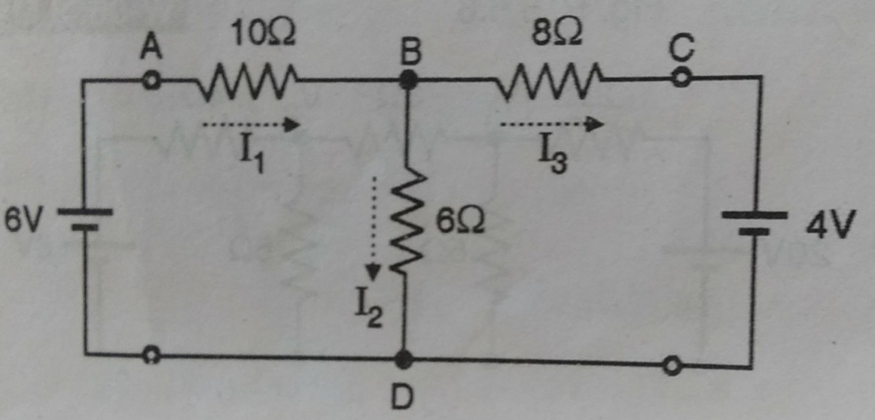

- Calculate the current through 3Ω resistance using Loop current method.
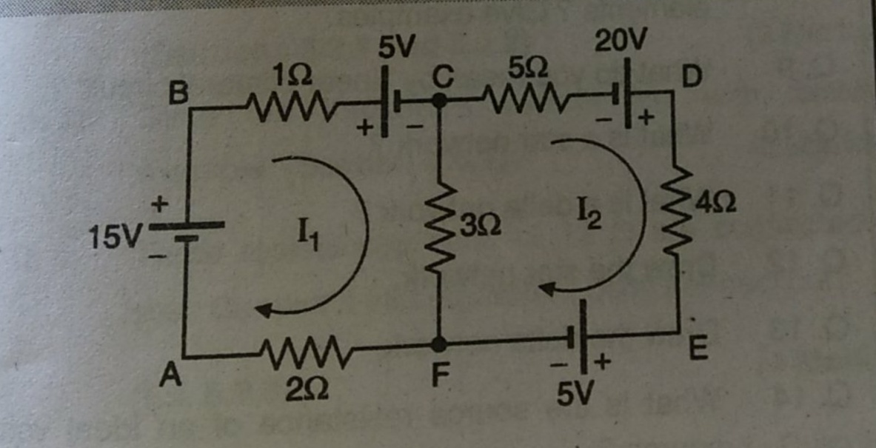

7. Compare Mesh Analysis and Node Analysis

CHAPTER-4 NETWORK THEOREMS(18)
2 MARKS
8. State Superposition Theorem.
9 .State Norton’s Theorem.
10. State Reciprocity Theorem
11.Define- i) Unlateral network ii) Bilateral network iii)Linear network
12. Define- i) Active network ii) Passive network iii)Non- Linear network
13. Write the condition to transfer Maximum Power to the load in a.c. circuits.

4 MARKS
14.State and explain Thevenin’s Theorem.
15. State Superposition theorem and write the steps to find the current through an
element by Superposition theorem.
16.Using Norton’s theorem find the Norton’s equivalent circuit for the network shown.
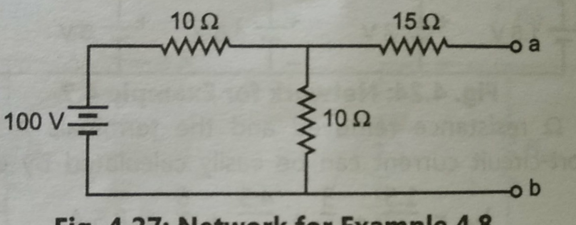

17. Verify Reciprocity Theorem for the circuit shown below.

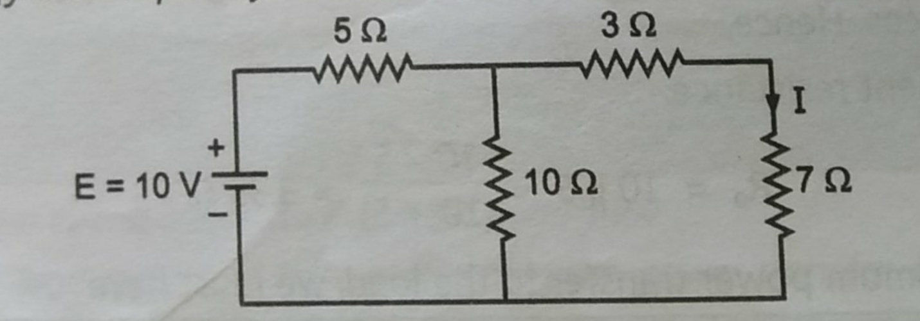

CHAPTER-5 TWO-PORT NETWORK(10)

2 MARKS
18. Write the equations of Open circuit Z parameters.
19. Define symmetrical network.
20. Define reciprocal network.
21. Write the condition for network to be reciprocal in terms of Y and Z parameters.

- MARKS
22. Find the impedence (z) parameter for the resistive circuit shown below.
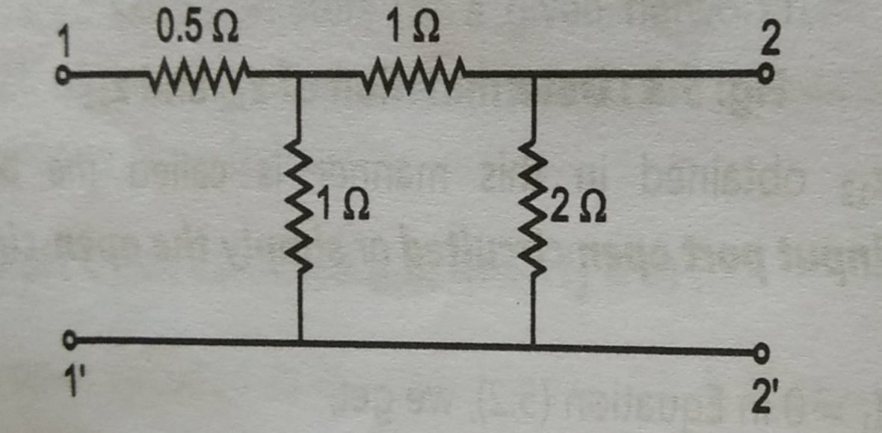

23. A symmetrical T-network has the following open-circuit and short-circuit impedances:
Zoc = 800Ω ( open circuit impedance)
Zsc = 600Ω(short circuit impedance)
Calculate impedance values of the network.
24 . Draw the two port network and determine the indicated parameters for the following
configurations.
i) Cascade configurations (ABCD parameter)
ii) Series configurations
iii) Parallel configurations.
25. Draw and explain short circuit admittance (y) parameter.

