QUESTION BANK (I Scheme)
Name of subject: Fundamentals of Power Electronics
Course Title: FPE (22326) Unit Test: I
Semester: 3I Program Code: EE

CHAPTER 1: Power Electronic Devices (06 marks) (CO1)
2 marks
- Draw the symbol and transfer characteristics of IGBT.
- Define primary and secondary breakdown in power transistor.
4 marks
- Describe with sketch the construction of IGBT.
- Draw the V-I characteristics of power transistor. Explain Quasi-saturation and hard saturation.
- Explain the concept of SET in aspects of Nano-technology.

CHAPTER 2: Thyristor Family Devices (17 marks) (CO2)
2 marks
- Interpret the following power electronic devices.
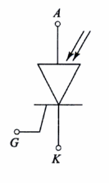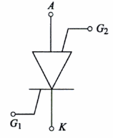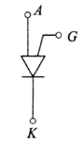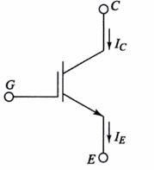
- (b) (c) (d)
- State the main difference between PUT & UJT.
- State the difference between GTO and conventional thyristor in terms of commutation and also state any two advantages over conventional Thyristor.
- Compare SCR & TRIAC (any four).
- Define the terms related to SCR:
- Latching current (c) Holding current
- On state voltage (d) reverse break over voltage.

4 marks
- Draw & explain the characteristics of SCR. State the effect of gate current on operation of SCR?
- Explain two transistor analogy of SCR. Write relation between anode current and Gate current.
- Describe SCR mounting and cooling with sketch.
- Draw the constructional diagram of GTO & explain its operation.
- Draw a structure of TRIAC with doping levels. Write operating principle and give two applications of it.
- Compare UJT & PUT on the basis of
- Construction
- Symbol
- Working Principle
- V-I characteristics
- Applications.
- Explain the operation of DIAC.
- State the need of protection circuits. Draw the basic diagram for: di/dt protection and dv/dt protection.
- Explain the operation of crowbar protection circuit with diagram.

CHAPTER 3: Turn ON and Turn OFF methods of Thyristors (14 marks) (CO3)
2 marks
- Define commutation. State the types of commutation.
- What is the need of isolation in pulse transformer in triggering circuits and give its two applications.
- Define triggering. List the type of triggering. Which method is mostly preferred?
- Differentiate between Natural and Forced commutation (any four).

4 marks
- Show the effect of resistance variations on firing & conduction angle with waveform in RC triggering.
- Explain the working of resistance triggering with neat waveforms.
- Draw & explain the operation of UJT relaxation oscillator. Write the expression for frequency.
- Draw class A commutation circuit with its neat waveform.
- Draw and explain the circuit diagram of Class C commutation.
- Explain the operation of opto coupler based triggering circuit with neat diagram.

