**Question Bank (I-Scheme)**

**Name of course: Electrical Circuits Unit Test: II**

**Subject code: 22324 (ECI) Semester: III Program: EE**

**Chapter 4: (Network reduction and principles of DC circuit analysis)**

**2 Marks**

1. Write the procedure of converting a current source into voltage source.
2. Distinguish clearly between loop and mesh.
3. Give four steps to solve mesh analysis.
4. Give four steps to solve nodal analysis.
5. **Marks**
6. Using mesh analysis, find loop currents I1 and I2 in the circuit, as shown in Fig

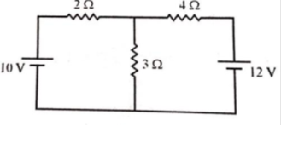

1. By using Nodal analysis calculate the current in 110 Ω resistor and p.d. across
2. Ω resistor as shown in fig.

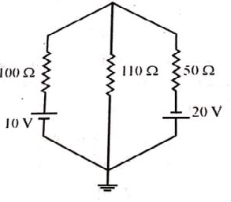

1. Using Node analysis, find current I in the circuit shown in Fig.

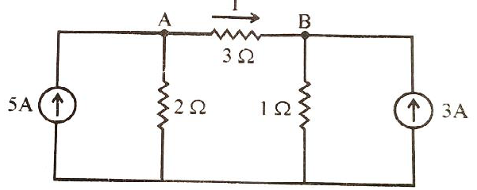

1. Using mesh analysis, find current I in the circuit shown in Fig

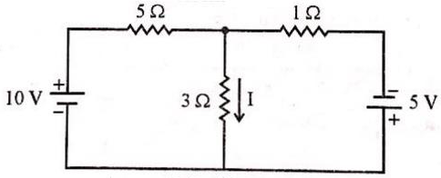

1. Using mesh analysis, find current in 10Ω resistance for the given circuit.

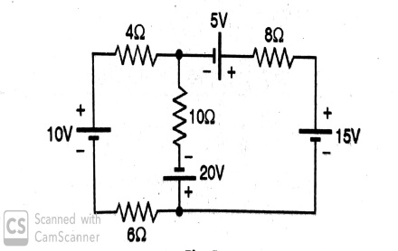

1. With neat circuit diagram, explain how to convert voltage source into current source and vice-versa.
2. Derive the formula for star to delta transformation.
3. Derive the formula for delta to star transformation.
4. Using star/Delta conversion, find the current drawn from the supply by the circuit shown in fig.

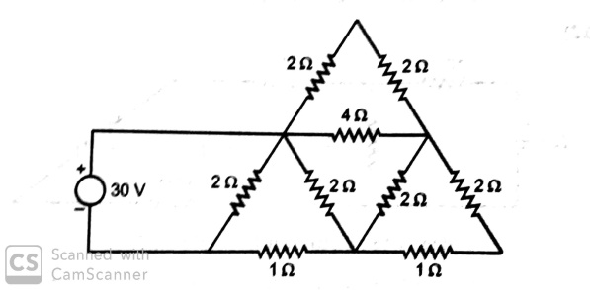

1. Using Node analysis, find current I in the circuit shown in Fig.

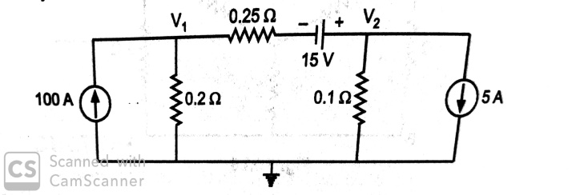

1. Apply Source conversion technique for the given circuit

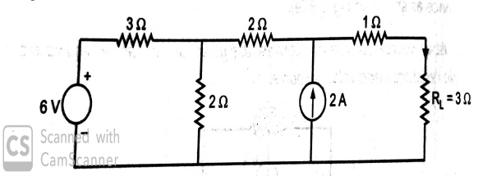

**Chapter 5: (Network Theorems)**

**2 Marks**

1. State superposition theorem applied to d.c. circuits.
2. State Thevenin’s theorem.
3. State Reciprocity theorem.
4. State the maximum power transfer theorem for DC circuit
5. State Norton’s theorem.

**4 Marks**

1. Convert following circuit as shown in figure into Thevenins circuit across A & B.

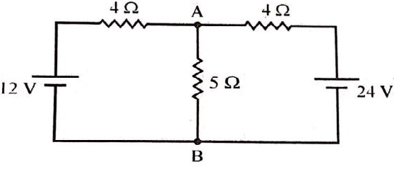

1. Use Norton’s theorem to find the current through 3 Ω resistance, for the circuit shown in figure.

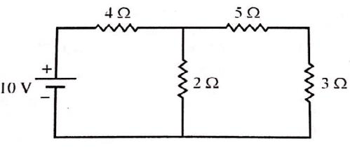

1. State the Thevenin’s theorem. Also write stepwise procedure for applying Thevenin’s theorem to simple circuits.
2. With neat circuit diagram, explain the concept of duality in Electric circuit. State any four examples (pairs) of duality in electric circuit.
3. For network shown in Figure determine value of R so that maximum power is delivered to it. Also compute the maximum power delivered.

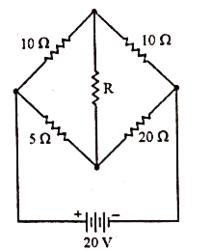

1. Apply superposition theorem to compute current I in the network shown in figure

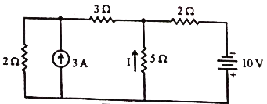

1. Using Norton’s theorem, find current through 1ohm resistances in Figure



1. State the superposition theorem. Also write stepwise procedure for applying superposition theorem to simple circuits.