Question Bank of Mechanics of Structures (22303)
Unit Test-II (Shift:-I)
Program: - Civil Engg. Course Code:- 22303
Semester: - III Course: - MOS

Question for 2 Marks
Chapter 05 (CO5)

- State any two assumptions made in the theory of pure bending.
- Define moment of resistance and neutral axis.
- State the shear stress equation and write the meaning of symbols used.
- Draw the shear and bending stress distribution diagram for solid rectangular section.
Chapter 06 (CO6)
- Define Radius of Gyration and Slenderness Ratio
- Define Effective length of column
- State the Assumptions made in Eulers Theory of long columns .
Chapter 04 (CO4)
- Define Shear Force and Bending Moment .
- Define point of Contra flexure
- State the different types of beams
Question for 4 Marks

Chapter 05 (CO5)

- A rectangular beam of 400 mm * 200 mm size is of wood material. If the permissible bending stress in wood is 2 MPa, calculate the moment of resistance of beam.
- Find the bending stress at 25 mm below the top edge of rectangular section 80 mm wide and 200 mm deep, if maximum bending moment is 4 KN-m.
- A cantilever rectangular M.S. section is 4 m in length. It carries load due to its self weight of 5 KN/m and the permissible bending stress in the M.S. is 5 MPa. Find the size of the section, if depth to width ratio is 2.
- A solid circular compression member 60 mm in diameter is to be replaced by a hollow circular section of the same material. Find the size of the section if the internal diameter is 0.6 times the external diameter.
- Determine the concentrated load , when placed at the free end of a cantilever beam of length 1 m will produce a shear stress 1.5 MPa. The cross-section is circular of diameter 100 mm.

Chapter 06 (CO6)
- A column having dia 200 mm is of length 3m .both the ends of the column are hinged .find Eulers Crippling load .
- A 4m length of a tube has a buckling of 2KN when used as column hinged at both the ends Calculate the buckling load for a 4.5m length of the same tube when used as a column if i) both ends are fixed ii) one end is fixed and other end is hinged ii) one end is fixed and other end is free .
- A rectangular Column of cross section 300mmx200mm and length of the column 3m find slenderness ratio when i) both ends are pinned joined ii) both the ends are fixed
- Determine by Rankines formula the safe load of the column of 5.5m length with both ends fixed can carry with a factor of safety 4 the properties of the section are A=1777mm2 Ixx = 11.6 x 106 Iyy= 0.84x106 mm4 fc=320N/mm2 a=1/7500

Chapter 04 (CO4)
- Draw SFD and BMD for the Cantilever beam span =4m =AE end A is fixed and AB= BC =CD= DE =1m over portion AC a u.d.l of 20KN/m acts and point loads of 20KN, 30KN AND 10KN Acts at B ,D AND E.
.
- Draw shear force and bending moment for simply supported beam as shown in Fig.

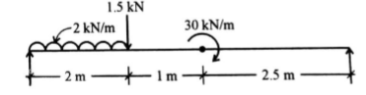

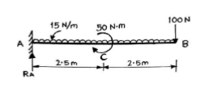
- Draw shear force and bending moment diagram for cantilever beam of 5 m span. Beam is loaded with udl of 15 N/m over entire span. Vertically downward point load of 100 N at its free and clockwise moment of 50 Nm at its mid span.

- A simple supported beam of span 6 m carries udl of 10 kN/m upto 2 m and couple of 5 kNm (clockwise) at 3 m respectively from left side support. Draw SFD and BMD with appropriate calculation.
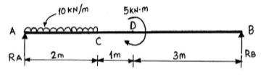

- A beam ABCD is supported at ‘A’ and ‘D’. AB=BC=CD=2m. It is subjected to udl of 10 kN/m over AB and a point load of 20kN at ‘C’ Draw shear force and bending moment diagrams.
- Draw shear force and bending moment diagrams for the cantilever beam loaded as shown in figure 1. Indicate all important values.
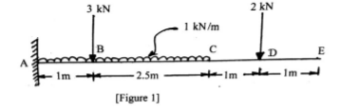

- Draw shear force and bending moment diagrams for the beam as shown in fig. 2.
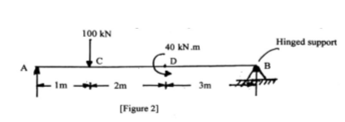

- Draw shear force and bending moment diagram for an overhang beam loaded as shown in fig.3
