I Scheme
Question bank – Unit test 1
EE2I
Fundamentals of Electrical Engg. (FEE) - (22212)
Unit I
Questions worth 2 Marks
1. Write any two differences between direct current and alternating current.
2. List any two effects of electric current. Give one example of each.
3. Define resistance. Also mention the factors upon which it depends.
4. State any two features of carbon composition resistors.
5. Classify electrical materials.
Questions worth 4 Marks
6. List any four types of resistors. Give one application of each.
7. A device stores 500 J and releases in the form of current of 40 A in the duration of 15 msec. Find
the terminal voltage.
8. Distinguish between Direct current and Alternating current. (Any four points)
9. An electric heater is rated as 220 V, 800 watts. Calculate resistance and current through it.
Determine the bill for using it for 4 hours at a rate of Rs. 4.5 per unit.
10. Define Ideal voltage source and practical voltage source. Draw the symbol for Each.
11. State any four advantages of A. C. over D. C.

Unit II
Questions worth 2 Marks
12. Define -
(i) Node
(ii) Loop for a DC circuit
13. Define unilateral and bilateral circuit.
Questions worth 4 Marks
14. Find current through 1W resistance of Figure No. 1 using Kirchhoff’s laws.
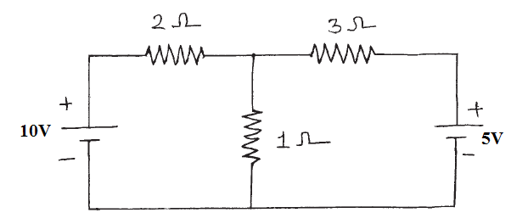
15. State and explain Ohm’s law.

16. Find resistance RAB from Figure No. 2.
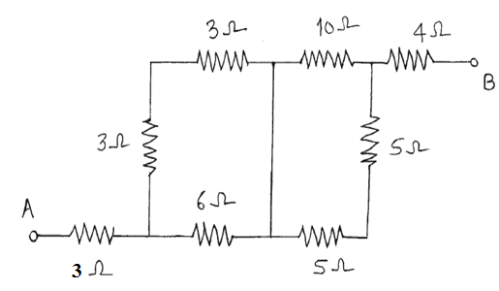
17. Calculate the equivalent resistance between points A and D in Fig No.1
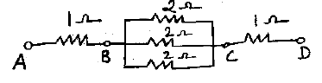

18. Prove that I₁=I*R₂ / R₁+R₂ in the parallel combination of two resistors R₁ and R₂.

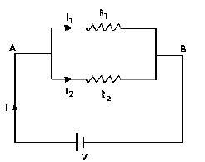
19. State and explain Kirchhoff’s current law and voltage law.

.
20. Compare series resistive circuit with parallel circuit on any four points.

Unit III
Questions worth 2 Marks
21. Define dielectric strength for a capacitor. What is its unit?

22. Define breakdown voltage and dielectric strength of a capacitor.
Questions worth 4 Marks
23. Draw a practical set-up to plot charging and discharging curves of a capacitor through a resistor.
Draw the curves.
24. Three capacitors 15mf, 18 mf and 12 mf are connected in a circuit. Find equivalent capacitance
when they are connected in -
(i) series
(ii) parallel
25. List any three types of capacitor. Give one application of any one type.
……………………………………………………………………………………………………………………

